***Doc for Steps to create Pull Request in GIT***

Please find below steps to create Pull Request,

**Step 1:** Right click on local branch and select **Create Pull Request**.

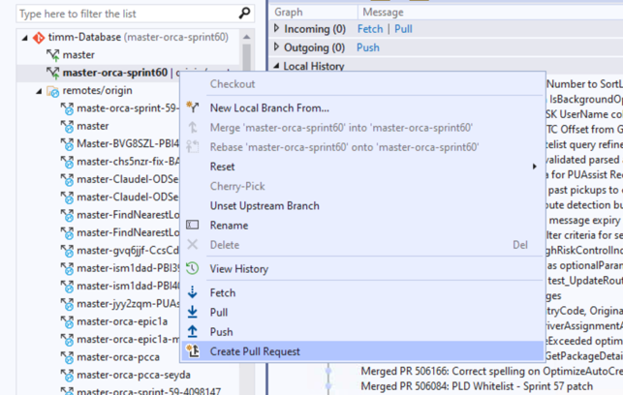

**Step 2:** It will load a page with create button. click on Create, it will launch a new page to build TIMM Database as below.

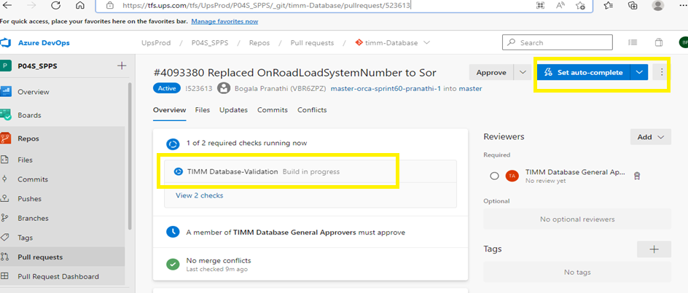

**Step 3:** After Build succeeded, expand **Set auto-complete** drop down and select Set auto-complete -> it will show a pop up with default selections -> click on Set auto-complete button.

**Step 4:** Will see below changes and then copy the below page URL and share with Sridhar for approval.

